

**CSE4062 2020 SPRING PROJECT**

**ANALYSIS OF ELECTRIC PRODUCTION OF A WIND TURBINE**

**Group: 8**

**Name ID Number Mail Addresses**

Furkan Can Ercan 150316044 [furkanercan98@gmail.com](mailto:furkanercan98@gmail.com)

Muhammed Avcı 150414007 [muhammedavci96@gmail.com](mailto:muhammedavci96@gmail.com)

Yasin Gök 150115058 [ygok.96@gmail.com](mailto:ygok.96@gmail.com)

**2) Exploratory Data Analysis**

In this part of our project, we tried to analyze our dataset in a way, which will improve our understanding of the data and the general situation of our process that our dataset depicts. To do this we utilized python programming language and its very useful libraries such as Pandas,Seaborn and Scipy. We used Jupyter notebook platform to arrange our coding and analyses systematically.

Our main dataset is composed of measurements of a Wind Turbine located in Yalova Turkey. It explains a Wind Turbine’s electric production process. It consists measurements from January 1st 00:00 to December 31st 2018 23:50 with 10 minutes gaps. Simply it includes measurements for every 10 minutes and these measurements are about electric production,therotical electric production as kilowatt/hour, Wind Speed as meter/second, wind direction angle as degree and date,time,month and day/night categories.

Even though it is a detailed dataset it does not include too many attributes to make our further purposes –regression analysis and building predictive models- easier. Therefore, we made some research to gather more data relevant with our processes.

After doing some researches we obtained data about weather conditions of the Yalova which is the location of our Wind Turbine. However, this weather dataset did not include measurements for every 10 minutes but it included measurements for a day as day and night. To merge these 2 datasets and compose our final dataset we assumed weather measurements to be consistent and same for every 10 minutes of measurements of our main data. After composing our final dataset we started to analyse it in a comprehensive manner.

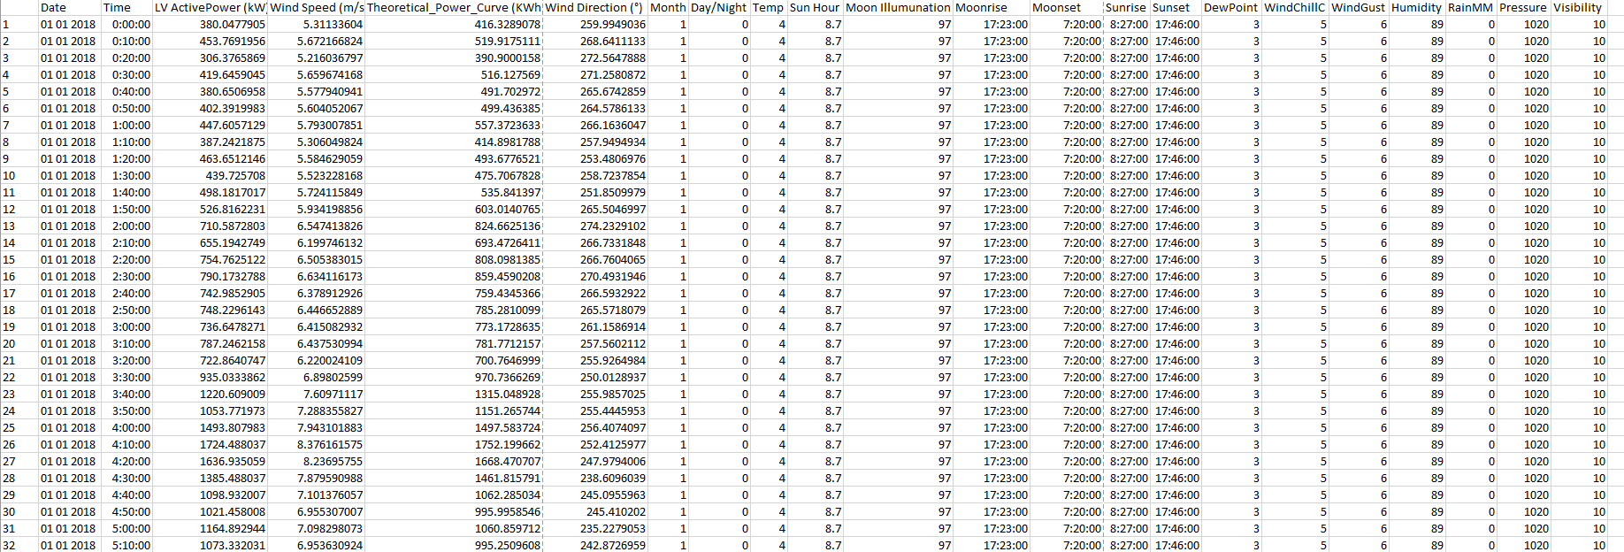

Figure 2.1: General demonstration of the Final Dataset

Our final dataset includes 50530 rows and 22 columns. It consists variables such as :

Date: Demonstrates the specific date of the measurement in dd/mm/yyyyy format. It is in text type.

Time: Demonstrates the specific time of the measurement in hh/mm/ss format. It is also in text type.

LV Active Power (kW) : It demonstrates the measured value of electricity production of the wind turbine in terms of kilowatts in corresponding time and date. It is a numeric attribute. It is also our target attribute. We will try to create a regression model to predict electricity production in the future.

Wind Speed: It demonstrates the speed of the wind in terms of meter/second in corresponding time and date. It is a numeric attribute.

Theoretical Power Curve: It demonstrates the theoretical calculation of the electricity production of the wind turbine in terms of kilowatt/hour, to do this calculation a theoretical formula is used which is based on wind speed and provided by the manufacturer firm of the Wind turbine. It is a numeric attribute.

Wind Direction: It demonstrates the angle of the wind in terms of degrees. It is a numeric attribute.

Month: It demonstrates the month of the corresponding measurement took place. It consists 12 different categories for each to represent 12 months. It is a categorical attribute.

Day/Night: It demonstrates the category of the corresponding measurement took place. It assumes from time 00:00 to 08:00 as night -0- and the rest of the day as day -1-. It is a categorical attribute.

Temp: It describes the temperature at the corresponding time being as a Celsius degree. It is a numerical attribute.

Sun Hour: It describes the time from sunrise to sun set as hours. It is a numerical attribute.

Moon Illumination: It describes the illumination degree of moon as a percentage. It is a numerical attribute.

Moon Rise: It describes the time of moonrise. It is a numerical attribute.

Moon Set: It describes time of moonset. It is a numerical attribute.

Sun Rise: It describes the time of sunrise. It is a numerical attribute.

Sun Set: It describes the time of sunset. It is a numerical attribute.

Dew Point Temp: It describes the temperature, which allows to creation of dew points as Celsius degree. It is a numerical attribute.

Wind Chill C: It describes the wind effect for the felt temperature as Celsius degree. It is a numerical attribute.

Wind Gust Kmph: It means sudden jumps at the wind speed which are shorter than 20 seconds in terms of kilometer/hour. It is a numerical attribute.

Humidity: It describes the humidity rate as a percentage. It is a numerical attribute.

Rain MM: It describes the raindrop fell as millimeter. It is a numerical attribute.

Pressure: It describes the pressure as milibars. It is a numerical attribute.

Visibility: It describes the visibility of an object in certain conditions. It is a meteorological measure. It is in terms of RVR runway visual range. It is a numerical attribute.

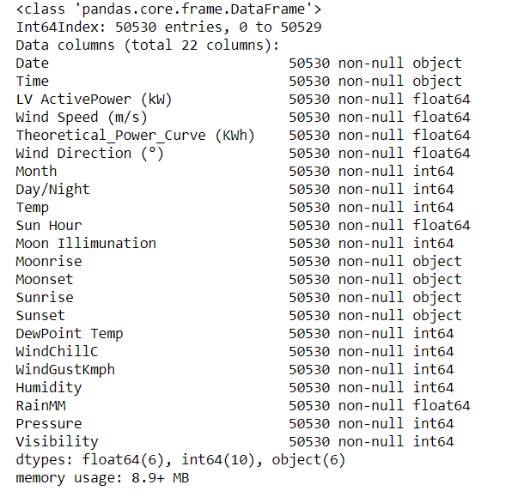

Figure 2.1 Decription of Dataset Attributes in Python

Our final dataset was a bit hard to demonstrate as a whole because it consists 50530 rows 22 columns so the first thing we did in our analysis was to divide it into 2 categories. We divide our 22 attributes as numerical and categorical attributes. After this division we made our deeper analysis in these 2 subsets. Of course our reason for this division was not only to divide our dataset into 2 subsets, but also to evaluate similar data together and to make a more focused analysis about

|  |  |
| --- | --- |
| **Attributes** | **Number of Zeros** |
| LV ActivePower (kW) | 10781 |
| Wind Speed (m/s) | 10 |
| Theoretical_Power_Curve (KWh) | 7749 |
| Wind Direction (°) | 75 |

Figure 2.2: Number of zero values

|  |  |  |
| --- | --- | --- |
| **Attribute** | **Ought** | **Is** |
| Date | 365 | 344-355 |
| Time | 144 | 11-144 |

Figure 2.3 Number of necessary observations and the number of observations in the data

different types of data accordingly. At first we did not realize the missing values but we found numerous rows with 0 values. We assume that these 0 rows are missing values but changed with 0 or may be they are because of the some problem of the recording device. Also on some days and some hours there are less observations then it should be.

**2.1 Analysis of Categorical Data**

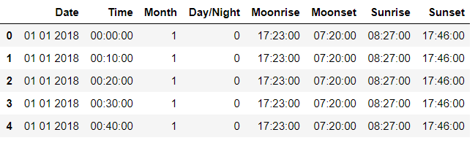

Figure 2.1.1 Demonstration of Categorical Attributes

Our dataset consist of 8 different categorical data. Actually in a different data set date and time might not be seen as a category but since our data set includes nearly 50000 measurements every day itself can be identified as a category with approximately 144 values. Similarly our Time attribute includes 10 minutes of gaps and same for everyday and in our whole dataset every gap nearly includes 365 values. So we decided to consider time and date attributes as categorical attributes. Month and Day/Night attributes are clear categories for Months explains months from January to December and Day/Night attribute indicates a specific time is in the daytime or night-time. Again similar to the Time attribute we accepted the Moonrise Moonset Sunrise and Sunset attributes as categorical variables but different than the time this acceptance was mostly for differentiating them from the numerical values.

**Analysis and Comments for Categorical Data**

|  |  |  |  |  |  |  |
| --- | --- | --- | --- | --- | --- | --- |
| **Category** | **Least Frequent** | **Frequency-Min** | **Most Frequent** | **Frequency-Max** | **Entropy** | **Number Of Categories** |
| Date | 02-10-18 | 11 | 31-12-18 | 144 | 8.47 | 356 |
| Time | 11:50 | 344 | 16:50 | 355 | 7.17 | 144 |
| Month | 11(November) | 3800 | 7(July) | 4464 | 3.58 | 12 |
| Day/Night | 0(Night) | 25172 | 1(Day) | 25358 | 0.99 | 2 |
| Moonrise | 13:30 | 39 | No Moonrise | 1726 | 8.13 | 306 |
| Moonset | 14:17 | 11 | No Moonset | 1728 | 8.14 | 309 |
| Sunrise | 17:49 | 127 | 17:36 | 1865 | 7.17 | 171 |
| Sunset | 7:01 | 61 | 5:32 | 2302 | 7.21 | 174 |
|  |  |  |  |  |  |  |

Figure 2.1.2: Statistics of Categorical Data

The Date attribute should be equal 144 since everyday is 1440 minutes and we take measurements in every 10 minutes but instead there are differences. There is not a single maximum which is but there are lots of days which does not have 144 measurements.

The time attribute should consist 365 observations for every 10 minute slice but instead it also differs from a minimum 344 observations to a max 355. This may be because of the lack of measurements in the missing days.

Month attribute is also changes and not stable but this may be explained with the different number of days for different months. It also may be because of the lack of observations to. It should be examined further.

Day/Night attribute is also should be equal for day and nights. There should be equal observations but there is not. However, still it is pretty close and entropy value is really close to 1 and it also shows an even distribution between day and night.

For the last 4 attributes the analysis do not value much for our processes ıt may value for a meteorological point of view but we did not consider them much.

**2.2 Analysis of Numerical Data**

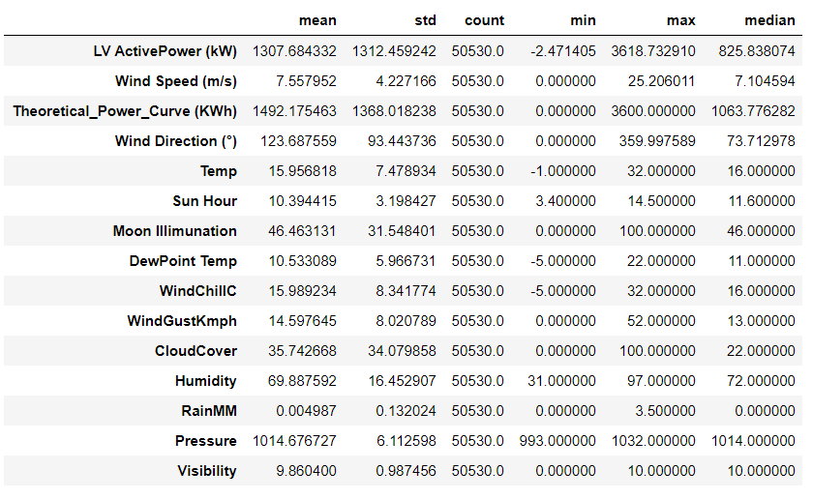

Figure 2.2.1 Descriptive Statistics for Numerical Data

For LV Active Power attribute mean and standard deviation is the same so we may say that standard deviation is relatively high. It also shows on the min and max values that the data of this attribute is very diverse. This diversity may be because of the extreme values or some outliers, because mean may be effected these values and the difference between median and mean is also says the same thing.

For Wind Speed variable standard deviation is not that high at least smaller than the mean but the min and max values also indicate a diverse data. However mean and median is relatively close so there may be not so much outliers.

Theoretical Power Curve is a guess for LV Active Power and it also shows on the statistics data is diverse statistics are very similar to LV Active Power attribute.

Win Direction data is also diverse and it means sudden direction changes and it may be related with Wind Gust variable because wind gust measures the speed of sudden wind bursts.

Pressure and visibility attributes are pretty stable has very small standard deviations they seem to be very consistent does not shows too much change.

The rest of the attributes are giving us ideas about more on the meteorological point of view than our process.

After making correlation calculations we may discover some relations but at the first glance they do not offer much information about our process.

For missing values that we mentioned above, most of the missing values are on the Active power and Theoretical Power Curve Attributes and they are not missing values but 0 values. Therefore, this effected our calculations and probably minimum values are automatically 0 for these attributes. So our comments about diversity should be revised. We decided to analyse our numerical one more time before model build and feature selection operations.